### nonlinear plasmid copy number model

We now consider the mechanisms for plasmid copy number controlling. For plasmid harboring the ColE1 origin, replication initiation process is controlled by RNA II-RNA I pairs. The copy number of plasmid $g_{i}$ satisfies the followed equation

$$\frac{dg_{i}}{dt}=k_{II}Q_{0}g_{i}−λg_{i} \text{(1)}$$

where $k_{II}$ is the RNA II initiation rate, $Q_{0}$ is the DNA replication abolish term that describes the RNA I repression, and is given by

$$Q_{0}=\frac{1}{1+R_{I}/K_{I}} \text{(2)}$$

We suppose the replication abolish process is a hyperbolic repression, $R_{I}$ is the concentration of RNA II, and $K_{I}$ is the inhibition constant. The concentration of RNA II, $R_{I}$, can be described by followed equation:

$$\frac{dR_{I}}{dt}=(k_{I}−k_{II})g_{i}−(ϵ_{I}+λ)R_{I} \text{(3)}$$

We suppose the RNA II transcription process is faster than the plasmid replication process, and the degradation of RNA II is more rapidly than the growth dilution rate $λ$, i.e. , $ϵ_{I}>>λ$ than Using the quasi-steady suppose, we have:

$$R_{I}^{*}=g_{i}⋅Δk/ϵ_{I} \text{(4)}$$

Now, we have the simplified model

$$\frac{dg_{i}}{dt}=k_{II}Q_{0}(g_{i})g_{i}−λg_{i} \text{(5)}$$

where, $g_{i}$ denotes the plasmid copy number, $R_{p}$ is the probability of the primer transcription results in replication. $λ$ is the growth rate. We rewrite the transcription rate of $k_{II}$ as $α_{II}$.

$$Q_{0}(g_{i})=\frac{1}{1+g_{i}/\tilde{K_{I}}} \text{(6)}$$

where, $\tilde{K_{I}}=K_{I}ϵ_{I}/Δk$.

The equilibrium of the plasmid copy number is given by

$$\frac{1}{λ}=\frac{1}{\tilde{K_{I}}k_{II}}g_{i}^{*}+\frac{1}{k_{II}} \text{(7)}$$

.

RNA II initials the plasmid replication  
RNA I binds to RNA II forming complex.

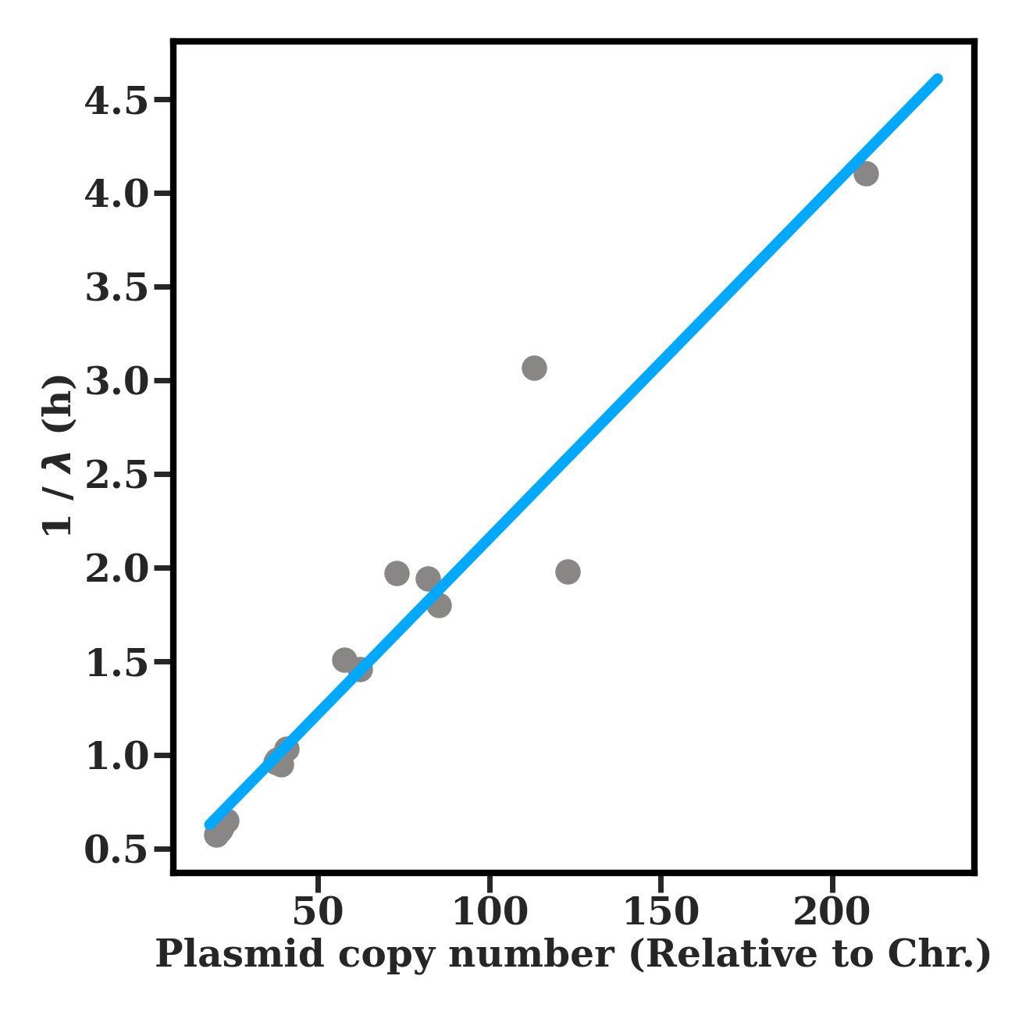

image-20211214100805225

The fitting $r^{2}=0.93$. the slope is 0.0187, and the interception is 0.283.

When the growth rate decreases, the slope becomes steep. It can be explained that the $k_{II}$ is the function of growth rate (RNA seq data of plasmid origin).

We suppose the $k_{II}$ is a constant, and $ρ=1$. We have the $k_{II}=3.54$.

Thus, we have $Δk/(ϵ_{I}K_{I})=0.0663$. we have the re-scaled $\tilde{K_{I}}=15.09$

Now, we have the simplified model

$$\dot{g_{i}}=α_{II}R_{p}(g_{i})g_{i}−λg_{i} \text{(8)}$$

where, $g_{i}$ denotes the plasmid copy number, $R_{p}$ is the probability of the primer transcription results in replication. $λ$ is the growth rate. We rewrite the transcription rate of $k_{II}$ as $α_{II}$.

$$R_{p}(g_{i})=\frac{1}{1+g_{i}/\tilde{K_{I}}} \text{(9)}$$

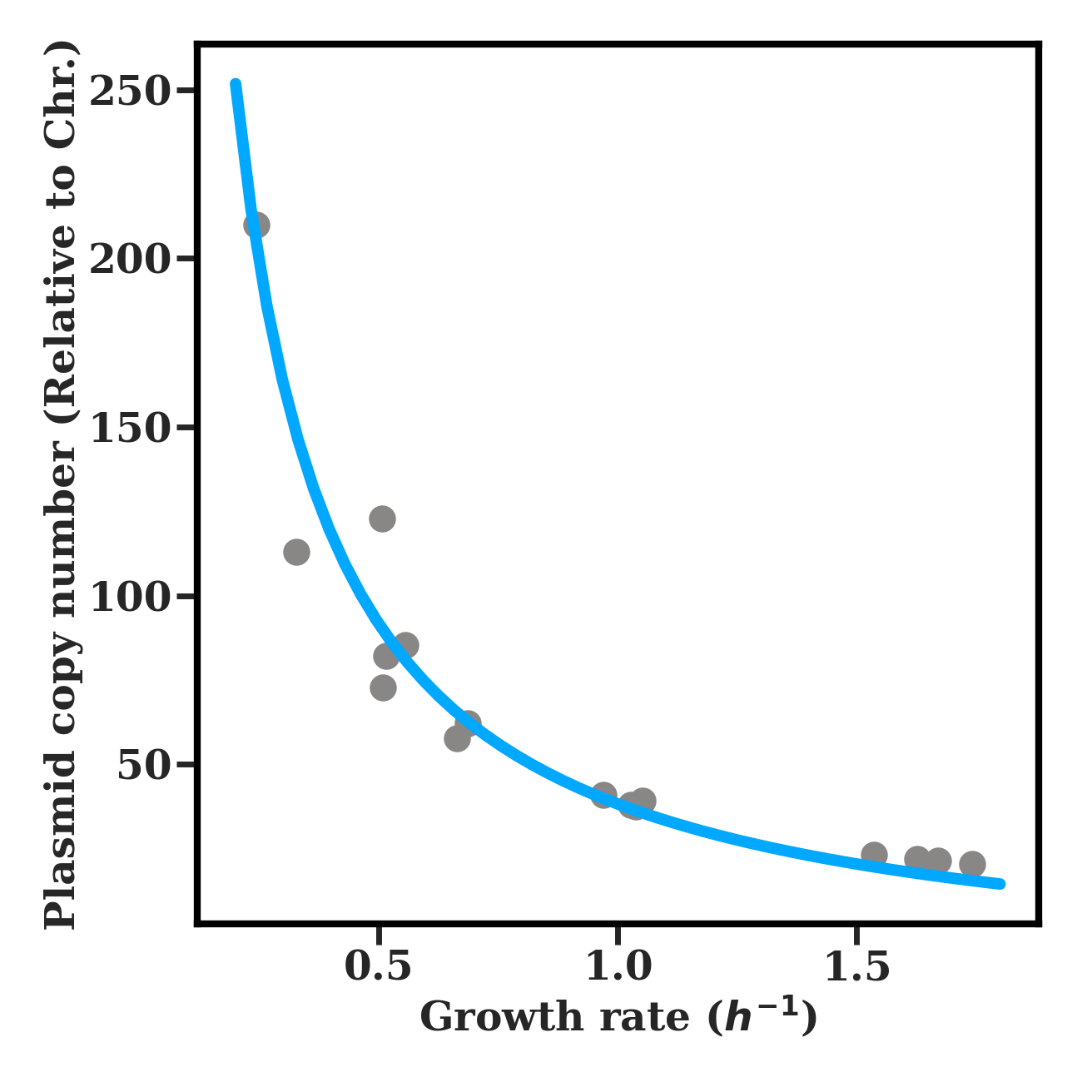

image-20211214095957639

The code for simulating the plasmid copy number: sub_model/plasmid_control.py

the code used in the Data Fitting Block

|  |  |  |  |
| --- | --- | --- | --- |
| Parameter | Value | Unit | Description |
| $k_{II}$ | 3.54 | $h^{−1}$ |  |
| $\tilde{K_{II}}$ | 15.09 | - |  |
|  |  |  |  |

### Perturbed growth rate condition

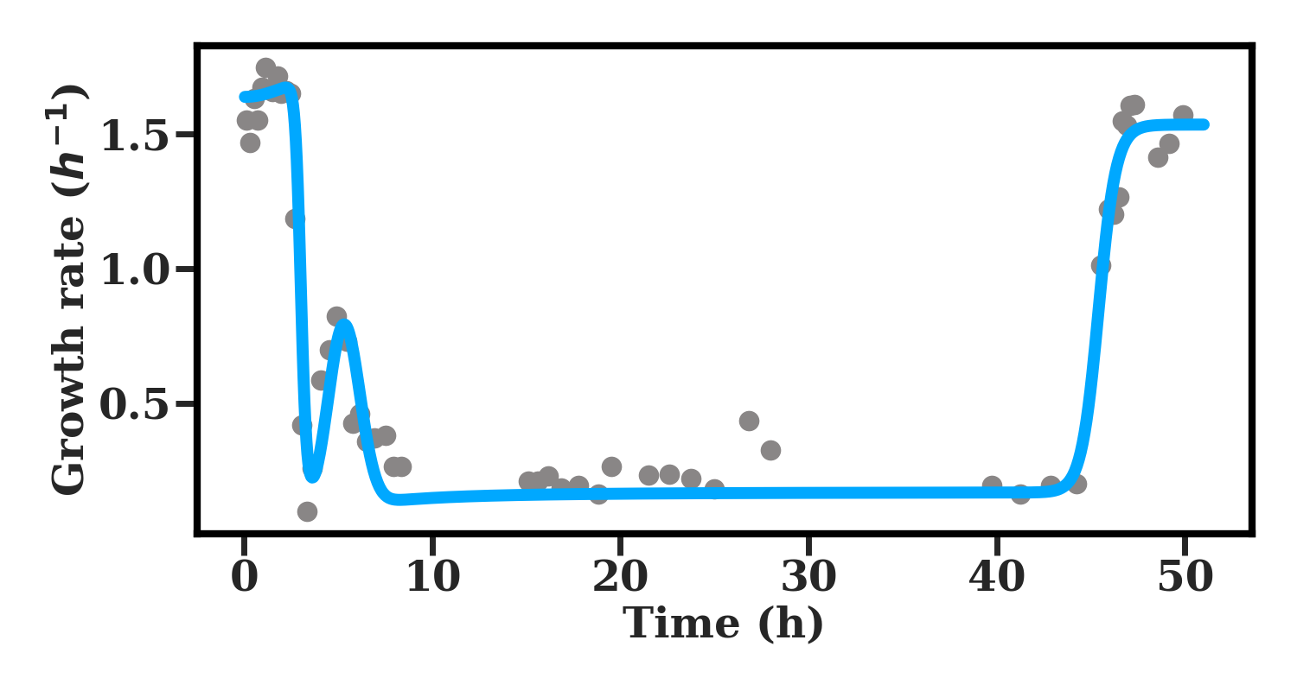

image-20220206224622224

M5_L3 down up shift  
Data: sub_model/growth_rate_down_up_shift_20210310.xlsx  
Code: sub_model/gr_updown_shift.py:164

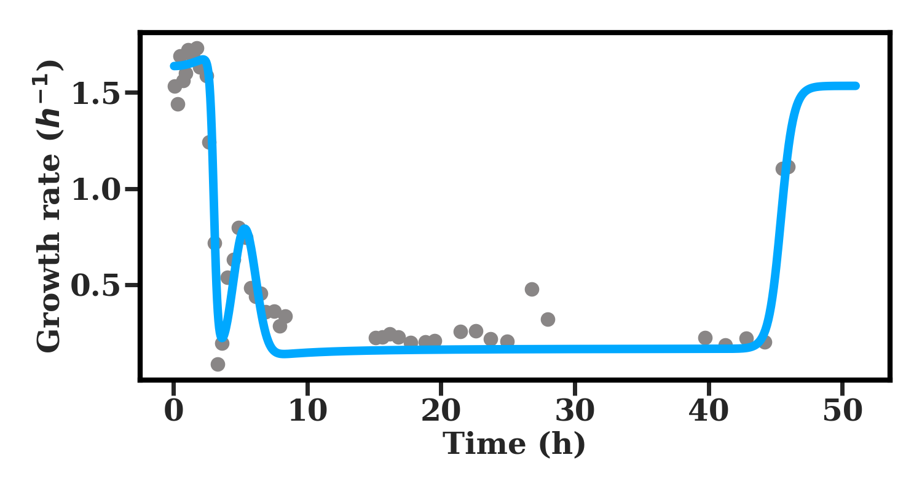

image-20220206224636566

L2 down up shift  
Data: sub_model/growth_rate_down_up_shift_20210310.xlsx  
Code: sub_model/gr_updown_shift.py:164

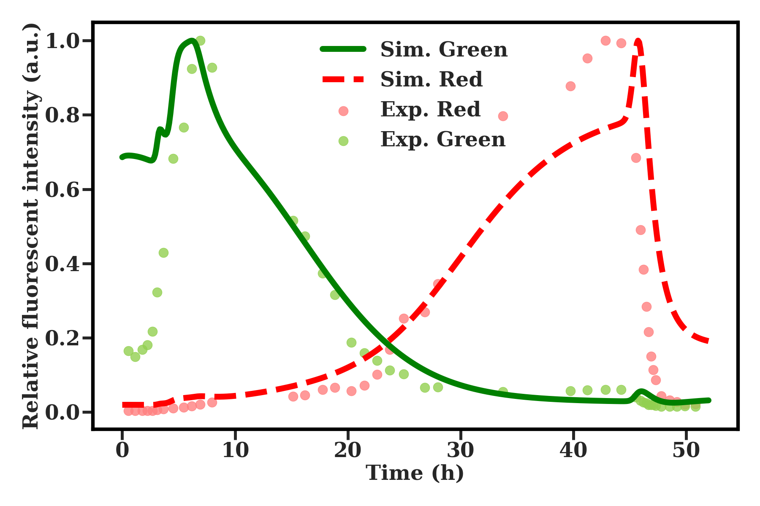

image-20220209144209987

code source: sub_model/gr_updown_shift.py:262

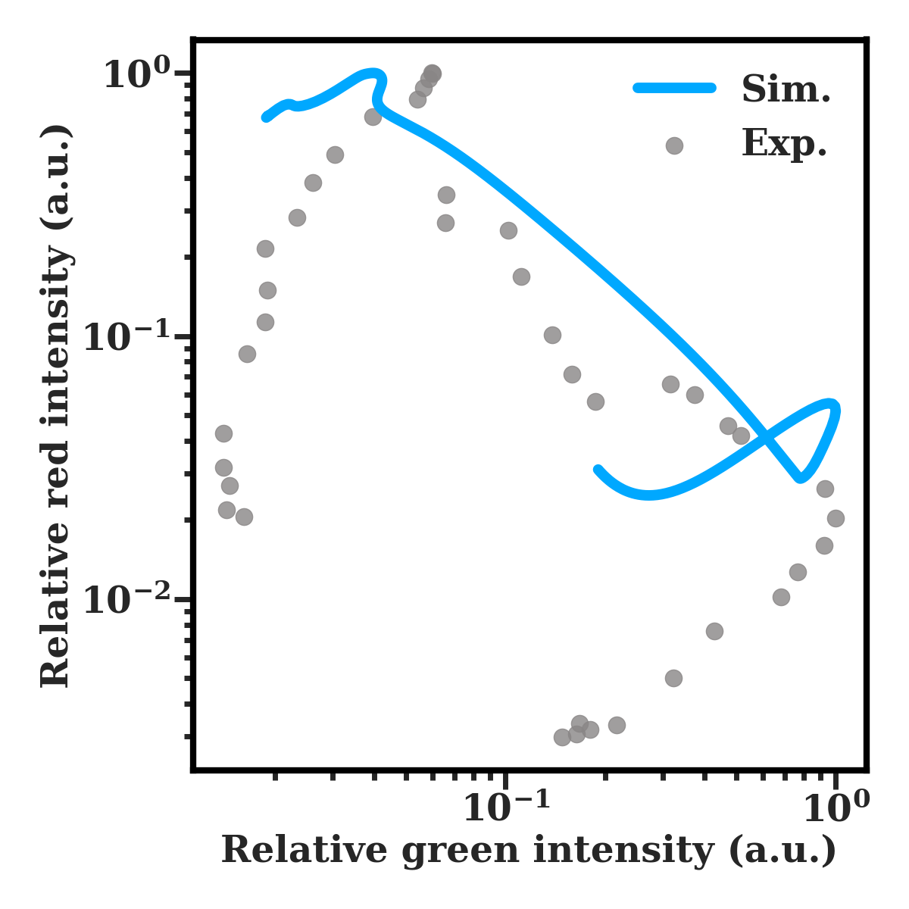

image-20220209143319719

code source: sub_model/gr_updown_shift.py:247

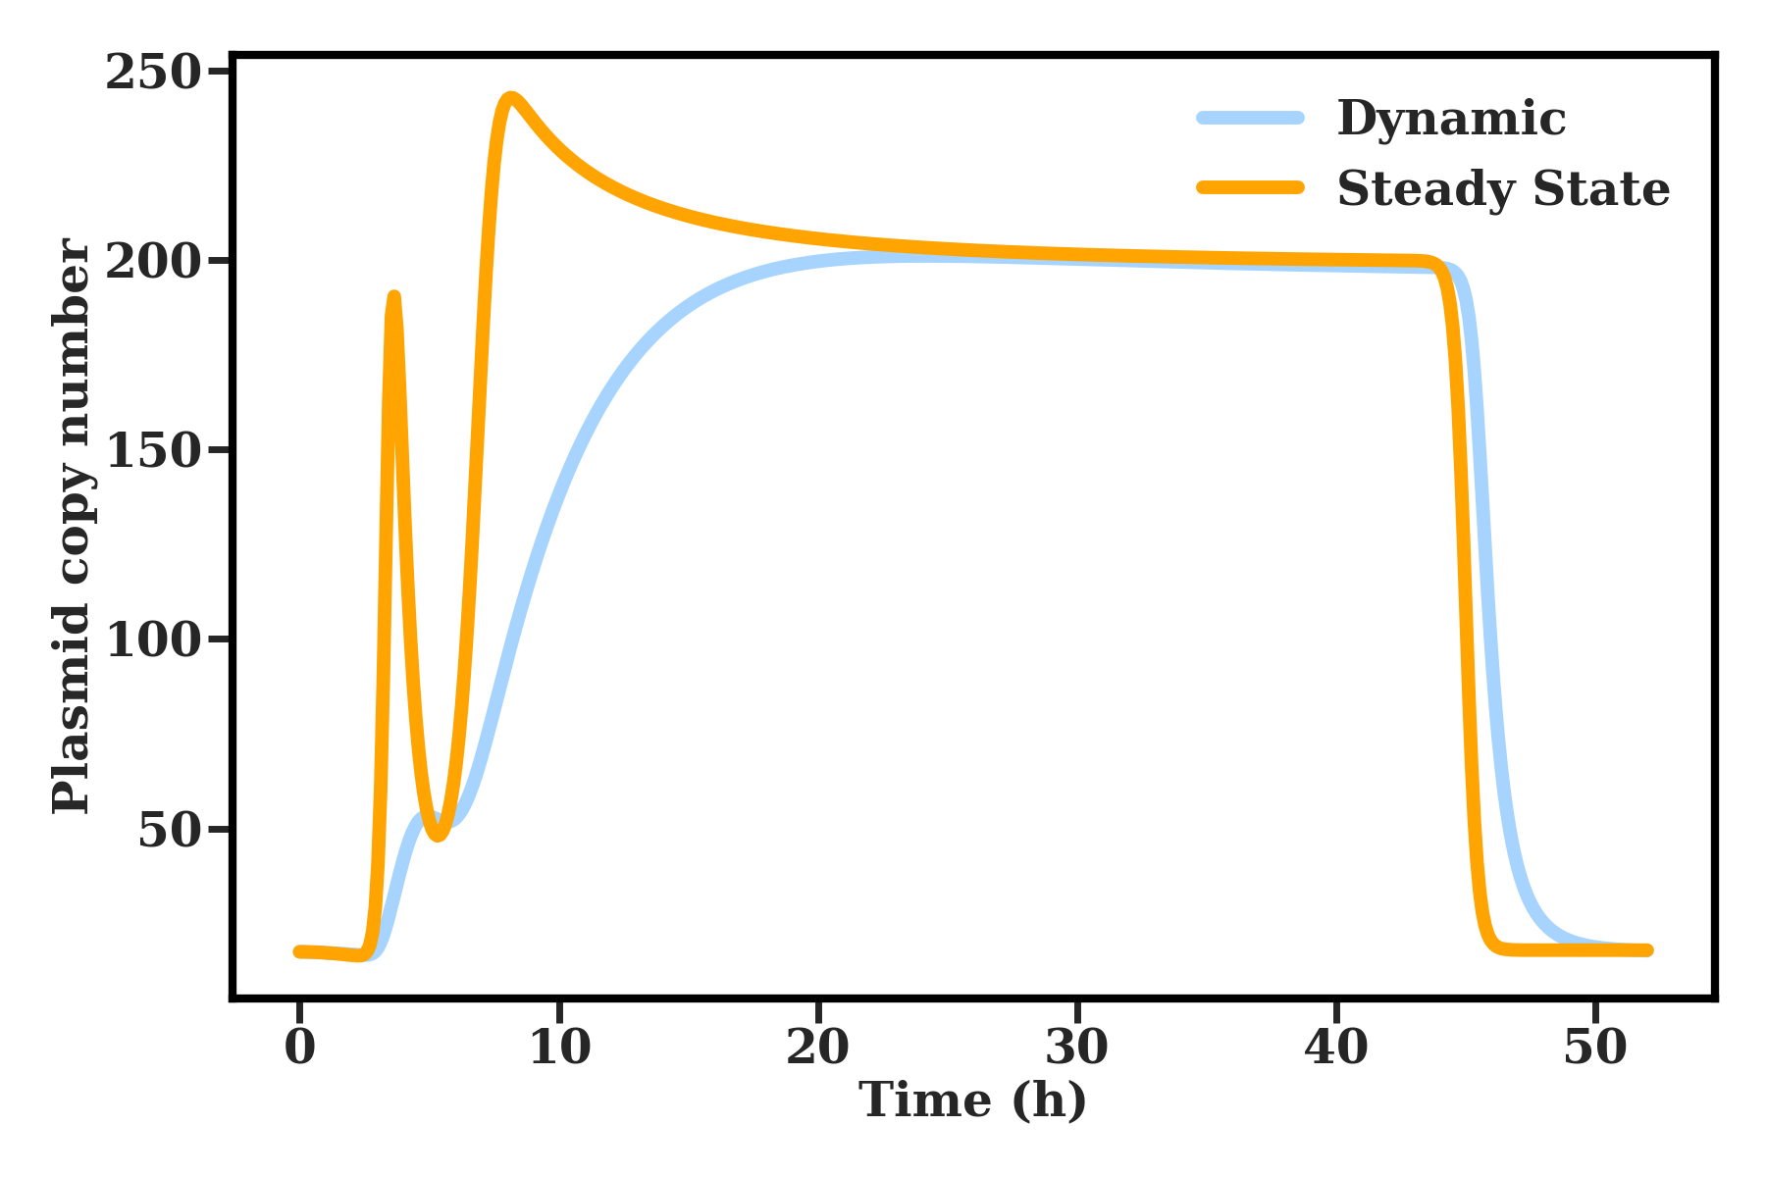

image-20220209184051953

Code: sub_model/gr_updown_shift.py:283